Hussain Ather

Daniel Ashley

S117

Lab Partner: Michael Peng

Observing the Atomic Emission Spectra for Various Elements

**Introduction:**

When electrons are excited in an atom, they jump to higher energy levels, and, upon returning to their original energy levels, the electrons give off energy in the form of different wavelengths of light (Iyengar). These wavelengths give a specific set of colors that can be observed with a spectroscope. Analysis of the colors observed, their wavelengths, and the distinct patterns of the colors gives information such as the identity of the element and the various energy levels of its electrons. Flame ionization and gas discharge tubes will be used to excite the atoms.

**Beginning Questions:**

* What other elements could be observed to give a better analysis of the patterns from these elements?
* How similar are Group 1 & 2 salts by their spectra?
* Are there any observable patterns among Noble gases?

**Procedure:**

First the spectroscope was used to find the wavelengths of the spectra of six different gases by choice. The apparatus was positioned so that the aperture was about one inch in front of the tube. The tube was turned on, and the wavelengths were observed by looking through the eyepiece. The focal piece, aperture size, and distance between spectroscope and tube were adjusted so that the lines would appear clear. This was repeated 2-3 times for greater certainty of what the emission spectrum was for each gas.

For the flame ionization, a small sample of the salt was placed in a collecting dish. A wet wire was dipped in water and placed in the dish to collect salt. The spectroscope was positioned similarly to the way it was for the discharge tube portion, but, this time, it was in front of the Bunsen burner. The Bunsen burner flame was started, and the salt was placed in the flame using the metal wire. The atomic emission spectrum was observed and this was repeated 2-3 times for more certainty. The flame color was recorded, as well. Three unknown salts were tested, as well, in order to determine their identities. A different wire was used for each salt, and each wire was rinsed with water to ensure no contamination.

Results:

1. Table 1: Wavelength(s), colors, and calculated energies observed for each element tube.

|  |  |  |  |
| --- | --- | --- | --- |
| **Element** | **Wavelength(s) observed (nm)** | **Color of light** | **Energy (J) of wavelength** |
| Hg | 545 | Green | 3.34x10-37 |
| H | 480 | Blue | 4.14x10-37 |
| 590 | Green | 3.37x10-37 |
| 660 | Red | 3.01x10-37 |
| Xe | 460 | Blue | 4.32x10-37 |
| 470 | Blue | 4.23x10-37 |
| 480 | Blue | 4.14x10-37 |
| 580 | Yellow | 3.43x10-37 |
| 620 | Orange | 3.21x10-37 |
| N | 420 | Violet | 4.73x10-37 |
| 540 | Green | 3.68x10-37 |
| 580 | Yellow | 3.43x10-37 |
| 620 | Orange | 3.21x10-37 |
| I | 420 | Violet | 4.73x10-37 |
| 540 | Blue | 3.68x10-37 |
| 640 | Red | 3.11x10-37 |
| Ne | 580 | Yellow | 3.43x10-37 |
| 610 | Orange | 3.26x10-37 |
| 620 | Orange | 3.21x10-37 |

The wavelength for each gas was recorded after viewing the flash of light from the discharge tube as much as possible. Shorter wavelengths gave off more energy, and longer wavelengths gave less. This is due to the mathematics of the calculation (shown below). If wavelength ($λ)$ is in the denominator, and it increases, then the resulting energy emitted would decrease.

1. Table 2: Wavelength(s), color, and calculated energy observed from each flame ionization test.

|  |  |  |  |
| --- | --- | --- | --- |
| **Salt** | **Wavelength(s) observed (nm)** | **Color observed** | **Energy (J) of wavelength** |
| CaCl2 | 560 | Green | 3.55x10-37, |
|  | 620-625 | Red | 3.21x10-37-3.18 x10-37 |
| SrCl2 | 610 | Red | 3.26x10-37 |
| LiCl2 | 675 | Red | 2.94x10-37 |
| NaCl | 590 | Orange | 3.37x10-37 |
| KCl | 590 | Orange | 3.37x10-37 |
| BaCl2 | 540-600 | Green | 3.68x10-37 - 3.31x10-37 |
| Unknown 077 | 590 | Orange | 3.37x10-37 |
| Unknown 092 | 680 | Red | 2.92x10-37 |
| Unknown 149 | 610 | Red | 3.26x10-37 |

The wavelength for each salt was recorded after viewing the flame through the spectroscope as much as possible. Each salt (including the unknowns) was a chloride salt. Shorter wavelengths gave off more energy, and longer wavelengths gave less. This is due to the mathematics of the calculation (shown below). If wavelength (is in the denominator, and it increases, then the resulting energy emitted would decrease. For BaCl2, a spectra was observed instead of a distinct line.

**Sample calculations**

Calculating the energy for each wavelength for each atom/ion

$$c=λν E=hν E=hc/λ$$

$$E=\frac{(6.626×{10}^{-34}Js)(3.00x{10}^{8}m/s)}{(545 nm)(\frac{{10}^{9}nm}{m})}=3.34x{10}^{-37} J$$

**Discussion:**

The results of each wavelength can be compared to the actual spectra (Köppen) to determine the accuracy of the experiment. The images are displayed in wavelengths of 10-10 m. Only the distinct lines in each image are to be compared. The spectra of colors behind the lines is only for reference.

Hydrogen

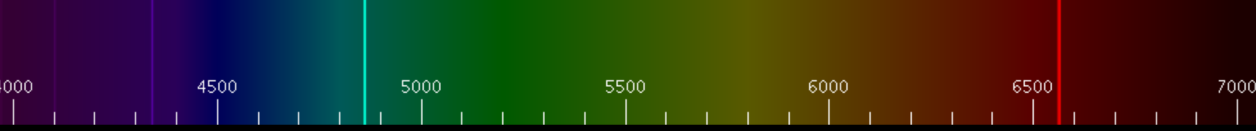

The two thick lines were observed (580 and 660 nm), but the faint violet line wasn’t.

Mercury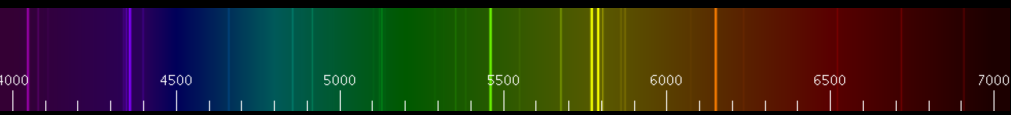

The thick green line was observed (545 nm), but the others weren’t.

Nitrogen

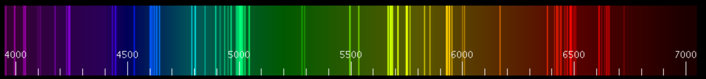

The thick violet line (420 nm), yellow line (580 nm), and orange line (620 nm) were observed, but the other lines weren’t.

Xenon

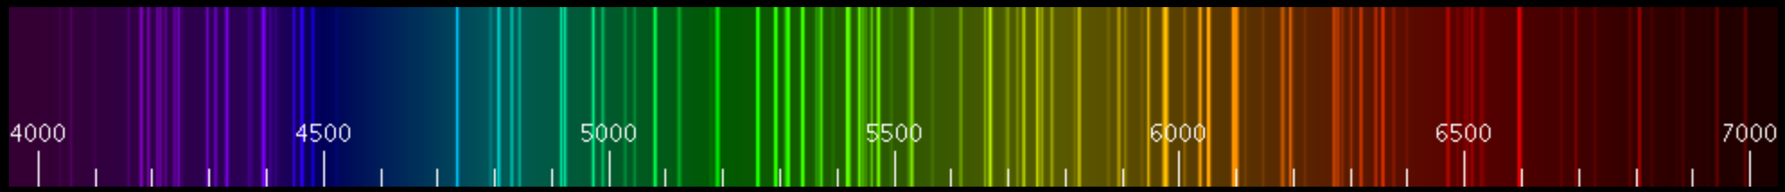

The light blue (470-480 nm) lines, green line (580 nm), and orange line (620 nm) were observed, but the other lines weren’t.

Neon

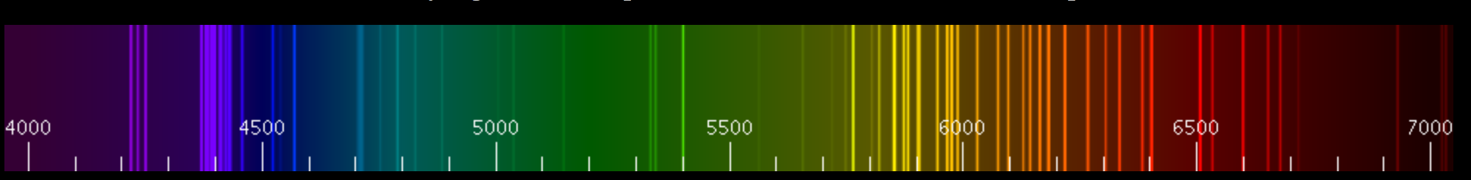

The yellow line (580 nm) and orange lines (610 and 620 nm) were observed, but the others weren’t.

For the ions, the following relative intensities were found (Kramida). The relative intensity indicates the brightness or intensity of that wavelength of light with respect to the others. In other words, the highest relative intensities correspond to the observed lines in the emission spectra.

Sodium (+1)

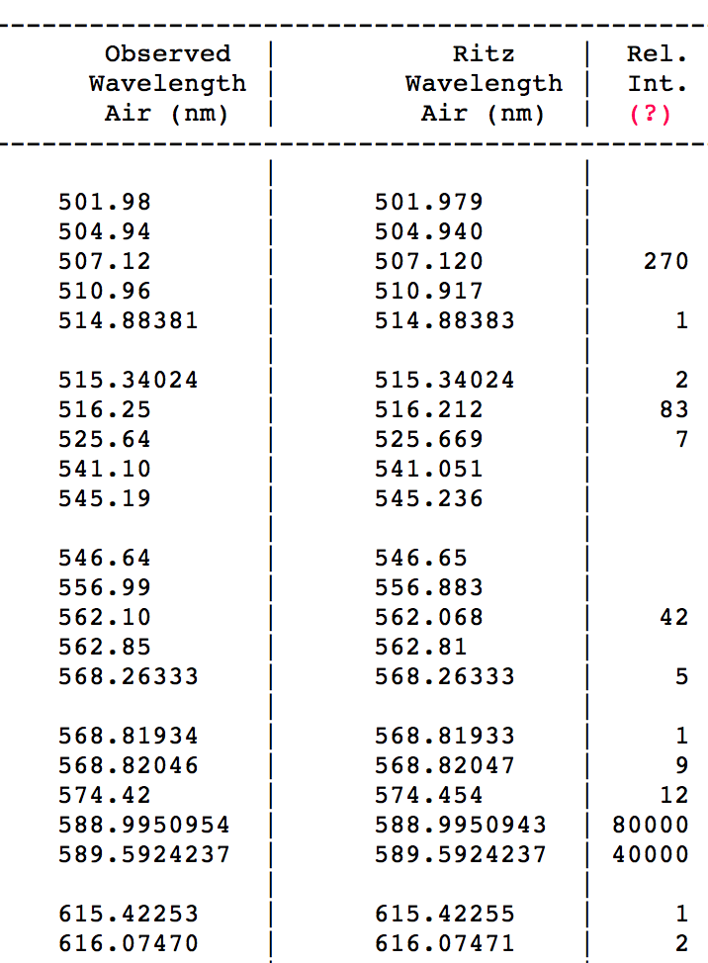

The highest relative intensities of 80000 and 40000 at 588.995 and 589.592, respectively, is consistent with the observation of a single wavelength (orange) at 590 nm.

Calcium (2+)

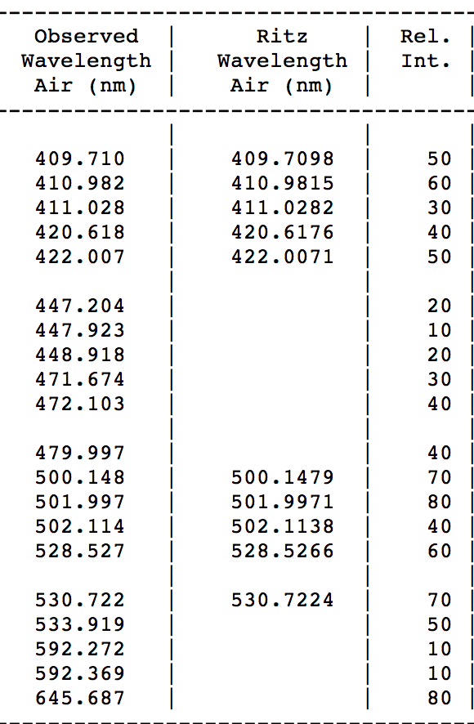

The relative intensities of 80 for 645.687 and 501.997 nm wavelengths each are inconsistent with our findings that 560 and 620-625 nm wavelengths.

Lithium (+1)

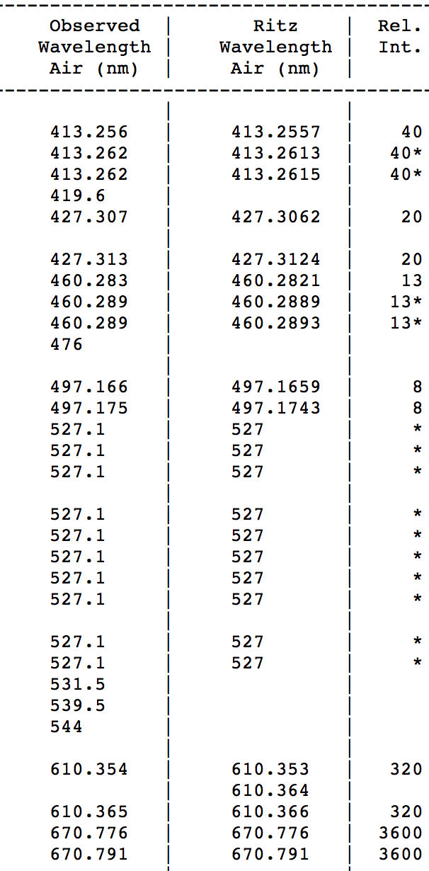

The highest relative intensity at about 670 nm from this data is consistent with the observtaion that the wavelength from the lithium ions were at 675 nm.

The external sources of the exact intensities of respective wavelengths for the other elements were much more difficult or unable to obtain.

From the observed data, the wavelengths observed from each discharge tube or ion sample may not have registered well enough due to the poor resolution of the spectroscope, especially at high and low wavelengths. This would explain why fewer wavelengths were detected than the wavelengths given from external soures. The similarity of the observed wavelengths to the actual results obtained from other sources shows a significant degree of accruacy in the experiment. The precision of the observations was not as significant, however, since only scale of 400-700 nm with intervals of 20 nm was available with the spectroscope. This would account for the slight differences between the size of the observed and actual wavelengths.

When the gas tube is charged or when the ion is set in the fire, the element experiences an increase in energy which raises the electrons of the atoms to higher orbitals. Then, the electrons fall back to their original respective orbitals due to the instability of this excited state. Also, since these energy levels are discrete, rather than in the form of a continuous spectral, the electrons must be confined in discrete energy levels around the atom. This is known as quantization (Iyengar).

Differences in energy were observed from different elements because the orbital energies differ between elements (Reck). This orbital energy depends on various forces, including the attraction of electrons to the nucleus. Elements with larger nuclei have a stronger attraction. There is also an electron repulsion between electrons. Elements with more electrons in the same energy level experience greater repulsion. These differences account for differences in emission spectra between elements of the same group (ie., noble gases comparison between Xe and Ne). By Koopman’s theorem, the magnitude of the first ionization energy equals the orbital energy. The energy given from the wavelengths emitted can be used to determine the orbital energies. By quantum mechanics, the discrete differences in energy can known. Each individual wavelength shows the discrete energy levels. These factors make the emission spectra of each element unique. Since each element has a unique spectra, from a comparison of the wavelengths of the unknown salts to the known salts, the unknowns 092, 077, and 149 were, respectively, concluded to be LiCl, NaCl, and CaCl2. The LiCl and NaCl matched the unknowns 092 and 077, respectively, more significantly than CaCl2 matched unknown 149, but the similarity between CaCl2 and unknown 149 was close enough to make a fairly safe guess. The difference may have been due to a slight misreading or error in resolution of the spectroscope.

Since there was a chloride ion in each salt sample, there might have been lines from the chloride ion in the observed emission spectra. However, this would theoretically affect each flame ionization test (including the unknowns) the same way, so the emission spectra of each cation would still be able to be compared. Other sources of error included the metal wire that was used for each flame ionization test. If the metal reacted with the fire, it could emit wavelengths of visible light that would be detected, as well. The experiment could be improved with an ability to record a still image of the atomic emission spectra as soon as it appears, rather than simply a flash on a screen for a very short amount of time. This would make it easier to observe the spectra lines. It could also be improved with greater precision by having smaller intervals of the wavelength scale on the spectroscope. This experimental setup could be used to determine the elements present in an ionic sample or in a gas. This could be used in forensics for evidence identification or in astronomy when observing radiation from various extraterrestrial bodies.

To answer the questions posed at the beginning, only two noble gases were tested, but bright, multiple spectral lines of colors were observed. Therefore, it is difficult to state a trend between noble gas spectral lines. Between Group 1 and 2 elements, as atomic number increases, more lines appear and lines become more spaced out. Other elements that could be observed would be beryllium, magnesium, rubidium, cesium, and francium in order to observe trends among the Group 1 elements, and beryllium and magnesium for Group 2 trends.

**Conclusion:**

The experiment successfully showed the unique atomic emission spectra of various gases and ions, giving insight to how the emission of electrons can vary in energy due to the energy levels of the electrons in different atoms. The concept of quanta is observed in the fact that there were distinct differences in colors and wavelengths of the line in the emission spectra, rather than continuous gradient-like spectra of colors. This provides applications for element identification and study of the energy levels of atoms.

References:

Iyengar, Srinivasan. Lab lecture.

Köppen, J. "Spectra of Gas Discharges." *Spectra of Gas Discharges*. National Institute of Standards and Technology, n.d. Web. 11 Sept. 2013.

Kramida, A., Ralchenko, Yu., Reader, J., and NIST ASD Team (2013). *NIST Atomic Spectra Database* (ver. 5.1), [Online]. Available: http://physics.nist.gov/asd [2013, September 17]. National Institute of Standards and Technology, Gaithersburg, MD.

Reck; Stone; Robinson; Arnold; “Principles of Chemistry and Biochemistry 1.” 6th edition